**DINESH.V**

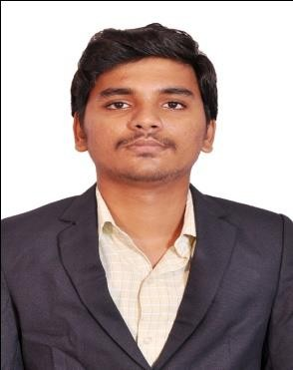



[**dinesh220198@gmail.com**](mailto:dinesh220198@gmail.com)

**6369575723**

**PROFESSIONAL SUMMARY:**

* An IT Professional with 1.4 years of experience in Database.
* Have exposure in the development and maintenance of MYSQL.
* Extensive experience in Report Generation, flexible search queries, Scripts.
* Worked with the Production team on clearing the defects raised on time without affecting the delivery timeline.
* Ability to learn new technologies and strong analytical skills.

**CAREER OBJECTIVE:**

To enhance my technical skills on current technologies and to work for the improvement of company’s growth.

**EMPLOYMENT SUMMARY:**

1. **Current Employer- School DB**

|  |  |
| --- | --- |
| **Organization** | **School DB,ST CARGO DB** |
| **Designation** | **Software Engineer** |
| **Duration** | **November 2019 to till date** |

**SKILLS:**

|  |  |
| --- | --- |
| **Programming Languages** | SQL,PL/SQL,linux commands |
| **GUI Tools** | MySQL **Workbench** |

**PROJECT DETAILS:**

|  |  |
| --- | --- |
| **Project #1** | ST CARGO DB |
| **Client** | ST CARGO |
| **Role** | Developer |
| **Company** | Femtosoft Techonology |
| **Location** | **Offshore**: Chennai |
| **Team Size** | **Project : 15** |
| **Tools Used** | **MySQL** |

**Project Description**:

ST Cargo Cargo strength lies in our experience, capabilities and infrastructure permitting us to consistently provide seamless transportation services. ST Cargo Cargo maintains an extensive and dependable scheduled route structure allowing our customers to integrate transportation solutions within their logistics program.

|  |  |
| --- | --- |
| **Project #2** | School DB |
| **Client** | EMIS |
| **Role** | Developer |
| **Company** | VENBA INFOTECH |
| **Location** | **Offshore**: Chennai |
| **Team Size** | **Project : 15** |
| **Tools Used** | MYSQL |

**Project Description**:

All types of schools such as government, government aided and private schools must immediately enter and submit on the EMIS website.

**EDUCATION:**

|  |  |  |  |  |
| --- | --- | --- | --- | --- |
| COURSE | INSTITUTION | BOARD /  UNIVERSITY | YEAR OF  PASSING | SCORE |
| B.TECH  Information Technology | Velammal Institute of Technology | Anna University | 2019 | 7.24 |
| HSC | ST.JOSEPH’S  Matric.Hr.Sec.School | State Board | 2015 | 88% |
| SSLC | ST.JOSEPH’S  Matric.Hr.Sec.School | State Board | 2013 | 92% |

**Personal Profile:**

**Name :** **V.DINESH**

**Father’s name :** Mr.E.Vinayagam

**Date of Birth : 22-01-1998**

**Languages Known :** Tamil and English.

**Declaration:**

I hereby declare that the above written particulars are true to the best of my knowledge and belief.

Yours faithfully,

**Date:**

**Place: Chennai. V.DINESH.**